**Process Manager Instructions**

* Open Vue360rx

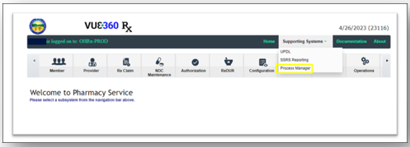

* A New tab will populate with the Vue360RX sign in request will pop up.
* Sign in with the same username and password used for Vue360Rx (HCLS =LEV\shortname).

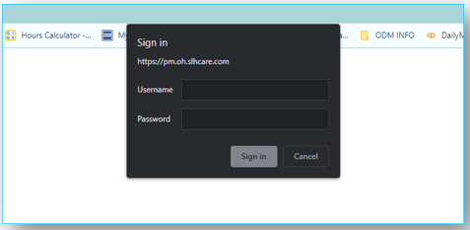

* Click on Process Manager Web Button to the Left.

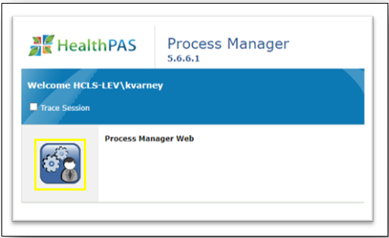

* To Upload a PA, Click Document Publisher
* Change the Filter Criteria to SPBM_PriorAuth

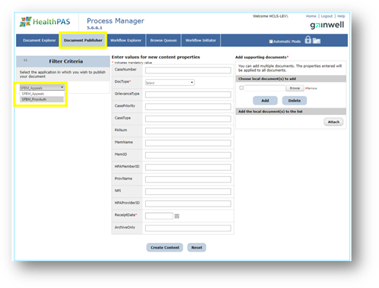

** **The Status is Always “LINKED”**

** The Member’s last name reads as [Last Name, First Name]

** The document must be a PDF File when attaching through Process Manager

** All highlighted fields need to be entered